

KUMARAGURU COLLEGE OF TECHNOLOGY
(An Autonomous Institution affiliated to Anna University, Chennai)
Post Box No: 2034, Coimbatore - 641049

24ADI204 - DATA SCIENCE AND VISUALISATION
LAB REPORT

AIRLINE FLIGHT DELAY ANALYSIS

Submitted by

Name | Roll Number
Anbusabarivasan M | 24BAD009
Ibrahim A | 24BAD035
Tejaswi K | 24BAD125
Namiya M | 24BAD404

in partial fulfilment for the award of the degree of
BACHELOR OF TECHNOLOGY
in
ARTIFICIAL INTELLIGENCE AND DATA SCIENCE

Department of Artificial Intelligence and Data Science
Kumaraguru College of Technology, Coimbatore - 641049

APRIL 2026

BONAFIDE CERTIFICATE

Certified that this project report “AIRLINE FLIGHT DELAY ANALYSIS” is the Bonafide work of “ANBUSABARIVASAN –24BAD009, IBRAHIM – 24BAD035, TEJASWI – 24BAD125, NAMIYA – 24BAD404“ who carried out the project work under my supervision.

SIGNATURE SIGNATURE

Dr. Sudharson D Ms. Rupashini P R
HEAD OF THE DEPARTMENT SUPERVISOR
Department of Artificial Intelligence Department of Artificial Intelligence
and Data Science, and Data Science,
Kumaraguru College of Technology, Kumaraguru College of Technology
Coimbatore – 641049. Coimbatore - 641049

The candidates with college register number 24BADXXX, 24BADXXX, 24BADXXX, 24BADXXX, 24BADXXX were examined in the Project Viva-Voce examination held on ……………...

Internal Examiner External Examiner

DECLARATION

I affirm that the project work titled “AIRLINE FLIGHT DELAY ANALYSIS” being submitted in partial fulfillment for the award of B. TECH Artificial Intelligence and Data Science is the original work carried out by us. It has not formed the part of any other project work submitted for the award of any degree or diploma, either in this or any other University.

ANBUSABARIVASAN – 24BAD009
IBRAHIM – 24BAD035
TEJASWI – 24BAD125
NAMIYA – 24BAD404

I certify that the declaration made above by the candidates is true.
Ms. Rupashini P R
Assistant Professor,

Department of Artificial Intelligence and Data Science, Kumaraguru College of Technology,
Coimbatore – 641049.

Executive Summary
Air travel is one of the most critical components of global transportation infrastructure, yet flight delays remain one of the most persistent and costly operational challenges in the aviation industry. This project, titled "Airline Flight Delay Analysis," was undertaken to systematically investigate the patterns, causes, and consequences of flight delays using real-world data from the United States Department of Transportation.
The dataset used is the 2017 U.S. Domestic Flight Delays dataset sourced from Kaggle, originally containing approximately 5 million flight records across 28 features. To ensure computational feasibility while maintaining statistical representativeness, a reproducible sample of 200,000 rows was extracted using random_state=42 in pandas.
The project followed a structured, end-to-end data science pipeline — covering data loading and inspection, missing value treatment, outlier detection and capping, exploratory data analysis, feature engineering, dimensionality reduction using PCA, and interactive dashboard development in Power BI.
Key findings from the analysis are as follows:
- Only 64% of flights operated on time, meaning roughly 1 in 3 flights experienced delays or cancellations.
- Late Aircraft Delay was the single dominant delay cause across all carriers, confirming a cascading propagation effect.
- ExpressJet (EV) and JetBlue (B6) were consistently the worst-performing carriers across multiple delay categories.
- Flights departing between midnight and 4 AM experienced the highest average delays, sometimes exceeding 100 minutes.
- Thursdays and Sundays were structurally the most delay-prone days of the week, likely due to peak travel demand and insufficient scheduling buffers.

The core insight of this study is that flight delays are not random. They follow identifiable temporal, operational, and carrier-specific patterns — patterns that airlines and airport operators can actively address through smarter scheduling, improved turnaround protocols, and data-driven resource allocation.

List of Abbreviations
Abbreviation | Full Form
EDA | Exploratory Data Analysis
PCA | Principal Component Analysis
OHE | One-Hot Encoding
KPI | Key Performance Indicator
DAX | Data Analysis Expressions
DOT | Department of Transportation
NAS | National Airspace System
IQR | Interquartile Range
DEP | Departure
ARR | Arrival
OP_CARRIER | Operating Carrier Code
CSV | Comma-Separated Values
ML | Machine Learning
API | Application Programming Interface

List of Tables
Table No. | Title | Chapter
Table 1 | Team Members | Title Page
Table 2 | List of Abbreviations | Preliminary
Table 3 | Dataset Feature Description | Chapter 2
Table 4 | Data Quality Report Summary | Chapter 3
Table 5 | Feature Engineering Summary | Chapter 5
Table 6 | Dashboard Visualization Types | Chapter 7
Table 7 | Key Findings Summary | Chapter 8
Table 8 | References | Chapter 10
Table 9 | Team Contributions per Week | Appendix

List of Figures
Figure No. | Description | Chapter
Figure 1 | Dataset initial load and structure | Chapter 2
Figure 2 | Dataset info() and describe() output | Chapter 2
Figure 3 | Missing value analysis output | Chapter 3
Figure 4 | Outlier detection using Z-score | Chapter 3
Figure 5 | Boxplot of delay columns before cleaning | Chapter 3
Figure 6 | Cleaned dataset summary | Chapter 3
Figure 7 | Flight status distribution (pie chart) | Chapter 4
Figure 8 | Airline-wise average delay (bar chart) | Chapter 4
Figure 9 | Monthly delay trend (line chart) | Chapter 4
Figure 10 | Correlation scatter plot (ARR vs DEP delay) | Chapter 4
Figure 11 | Distribution plots before transformation | Chapter 5
Figure 12 | Distribution plots after log transformation | Chapter 5
Figure 13 | Skewness correction comparison | Chapter 5
Figure 14 | Feature scaling output | Chapter 5
Figure 15 | Correlation heatmap | Chapter 6
Figure 16 | PCA explained variance (scree plot) | Chapter 6
Figure 17 | PCA 2D scatter plot | Chapter 6
Figure 18 | Power BI Dashboard - Page 1 (Overview) | Chapter 7
Figure 19 | Power BI Dashboard - Page 2 (Heatmap & Carriers) | Chapter 7

Chapter 1: Introduction

1.1 Background of the Problem
Air transportation forms the backbone of modern mobility, connecting cities, economies, and communities across vast distances. In the United States alone, thousands of domestic flights operate every single day, making schedule reliability one of the most important performance metrics for the aviation industry. Flight delays not only inconvenience millions of passengers but also result in significant financial losses for airlines — estimated at billions of dollars annually — through increased fuel consumption, crew overtime, gate conflicts, and passenger compensation obligations.
What makes flight delays particularly complex is their cascading nature. A single delayed aircraft on one route can disrupt multiple subsequent flights across entirely different routes, creating a network-wide ripple effect that worsens as the day progresses. This phenomenon, commonly referred to as the "Late In, Late Out" effect, means that early-morning disruptions can propagate through an airline's entire daily operation. Understanding when, where, and why delays occur is therefore essential not just for operational improvement, but for the long-term reliability and competitiveness of the aviation sector.

1.2 Importance of the Study
This study holds importance for several stakeholders simultaneously. Airlines can leverage delay pattern analysis to redesign schedules, identify underperforming routes, and reduce avoidable costs. Airport authorities can use the insights to better manage gate assignments, ground crew deployment, and traffic flow during high-risk time windows. For passengers, improved airline reliability translates directly into reduced stress, fewer missed connections, and a better overall travel experience.
From a data science perspective, this dataset presents a rich, real-world challenge. It involves handling missing values, correcting skewed distributions, encoding high-cardinality categorical variables, managing outliers, and extracting meaningful signals from millions of records. These are exactly the kinds of problems encountered in professional data science practice, making this project an excellent applied learning exercise.

1.3 Objectives of the Project
- To perform thorough data cleaning and preprocessing on the 2017 U.S. flight delays dataset, ensuring it is analysis-ready.
- To conduct univariate and bivariate exploratory data analysis to uncover meaningful patterns in flight delay behaviour.
- To apply feature engineering techniques including RobustScaling, One-Hot Encoding, and log transformation for skewness correction.
- To reduce dimensionality using Principal Component Analysis (PCA) and identify the features that contribute most significantly to delays.
- To build an interactive Power BI dashboard that communicates key insights clearly and effectively to both technical and non-technical audiences.

1.4 Scope of the Project
This project is limited to domestic U.S. flight operations recorded during the calendar year 2017. The analysis is based on a reproducible 200,000-row sample drawn from the full dataset of approximately 5 million records. The scope covers the complete data science pipeline — from raw data ingestion to interactive dashboard visualization — but intentionally excludes predictive modelling and real-time data integration, both of which are identified as areas for future work.

Chapter 2: Dataset Description

2.1 Source of Dataset
The dataset was sourced from Kaggle — specifically, the U.S. Department of Transportation Flight Delays and Cancellations dataset (https://www.kaggle.com/datasets/usdot/flight-delays). It is published by the Bureau of Transportation Statistics and contains official, government-verified records of all domestic U.S. flights operated in 2017. The dataset is widely used in the data science community for delay analysis, time-series modelling, and aviation research.

2.2 Dataset Size
The original dataset contains approximately 5 million rows and 28 columns. Given the computational constraints of Google Colab and the academic scope of this project, a reproducible sample of 200,000 rows was extracted using pandas with random_state=42. This approach ensures that results are reproducible across all team members and machines, while preserving the statistical distribution of the original data — a standard practice in large-scale data science workflows.

2.3 Description of Features
The dataset contains 28 columns covering flight scheduling, operational status, and delay attribution. The key features are described below:
Column Name | Description
FL_DATE | Date of the flight
OP_CARRIER | Operating airline carrier code (e.g., AA, DL, EV)
ORIGIN | Origin airport code
DEST | Destination airport code
DEP_TIME | Actual departure time (HHMM format)
ARR_TIME | Actual arrival time (HHMM format)
DEP_DELAY | Departure delay in minutes (negative = early)
ARR_DELAY | Arrival delay in minutes (negative = early)
CANCELLED | Binary flag: 1 if flight was cancelled, 0 otherwise
DIVERTED | Binary flag: 1 if flight was diverted, 0 otherwise
CARRIER_DELAY | Delay in minutes attributed to the carrier
WEATHER_DELAY | Delay in minutes attributed to weather conditions
NAS_DELAY | Delay due to National Airspace System congestion
LATE_AIRCRAFT_DELAY | Delay caused by a late arriving aircraft on the same route
SECURITY_DELAY | Delay due to security issues at the airport
DISTANCE | Distance between origin and destination in miles
TAXI_OUT | Taxi-out time in minutes (gate to runway)
TAXI_IN | Taxi-in time in minutes (runway to gate)

2.4 Initial Data Issues
Upon initial inspection using .info() and .describe() in Python, several data quality issues were identified that required attention before any analysis could proceed:
- Missing values were present in all five delay attribution columns (CARRIER_DELAY, WEATHER_DELAY, NAS_DELAY, SECURITY_DELAY, LATE_AIRCRAFT_DELAY), primarily for on-time and cancelled flights where delay cause data was not recorded.
- An empty column labelled "Unnamed: 27" contained no useful data and needed to be dropped entirely.
- Extreme outlier values were present in DEP_DELAY and ARR_DELAY, with some records showing delays exceeding several hundred minutes — suggesting either data entry errors or genuinely exceptional disruptions.
- Certain columns had mixed or inconsistent data types that required standardization before analysis.

The following screenshots show the initial dataset load and structure inspection:

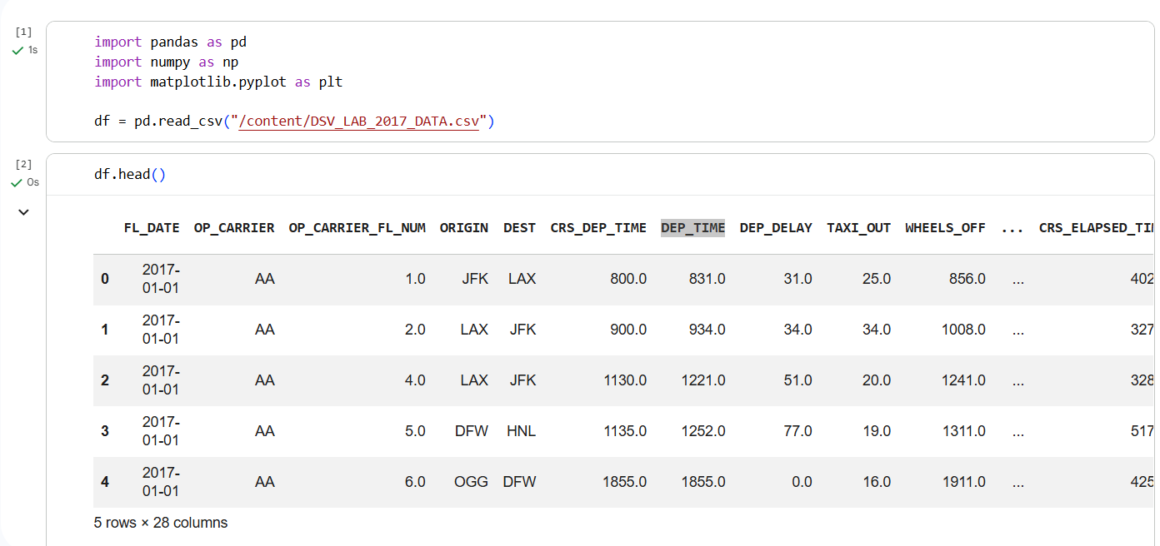
Figure 1: Dataset initial load output showing shape and column structure
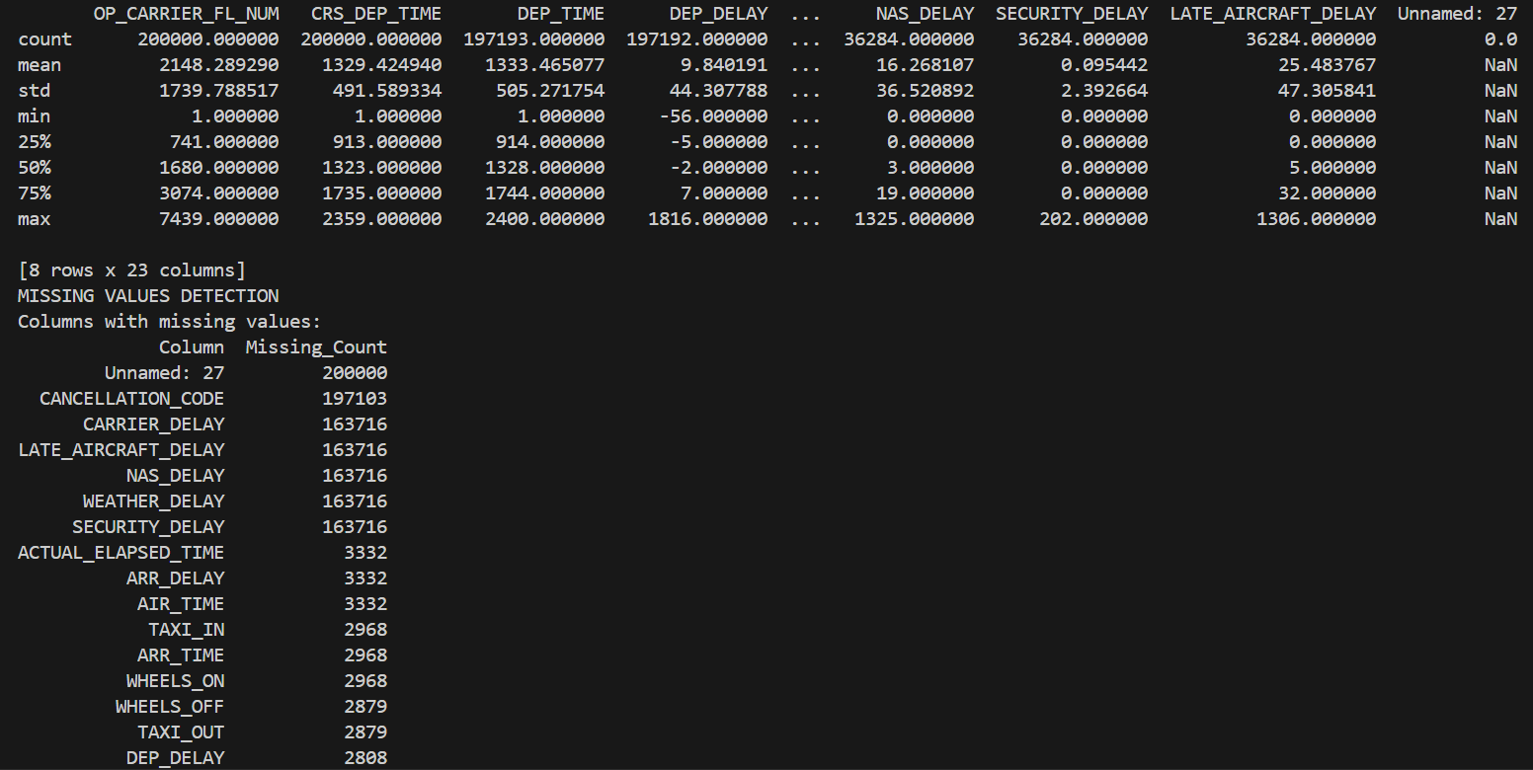
Figure 2: Output of df.info() and df.describe() showing data types and statistical summary
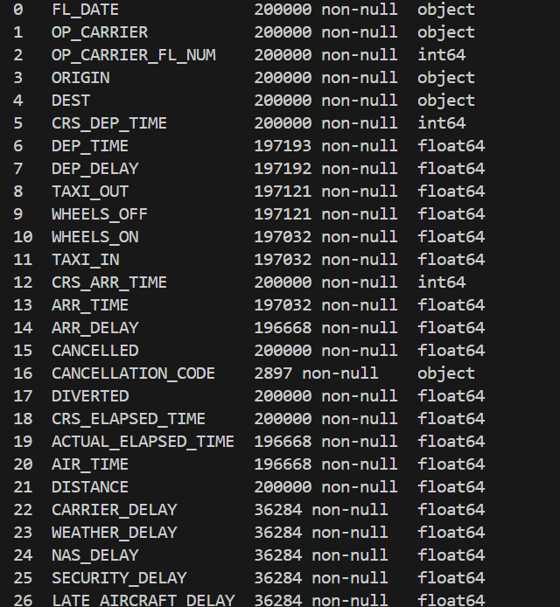
Figure 3: Statistical summary of key numerical columns

Chapter 3: Data Preprocessing and Cleaning

3.1 Data Loading and Inspection
The dataset was loaded into a pandas DataFrame using pd.read_csv(). Initial inspection was carried out using .info() to examine column data types and identify null counts across all 28 columns, and .describe() to review statistical summaries for numerical features. This step confirmed the presence of missing values, extreme outliers, and the empty column mentioned in the previous chapter.

3.2 Handling Missing Values
Missing values were identified systematically using isnull().sum() across all columns. Two distinct imputation strategies were applied based on the data type of each column:
- Numerical columns (DEP_DELAY, ARR_DELAY, and all five delay cause columns): Median imputation was used. Median is the preferred choice here because delay columns are heavily right-skewed — using mean imputation would introduce artificially inflated values, biasing the analysis. Median is robust to extreme values and better reflects the typical delay experience.
- Categorical columns (OP_CARRIER, ORIGIN, DEST): Mode imputation was applied, filling gaps with the most frequently occurring value. This approach preserves the existing categorical distribution without introducing new, potentially misleading categories.
- The empty column "Unnamed: 27" was dropped entirely using df.drop(), as it contained no usable information across all rows.

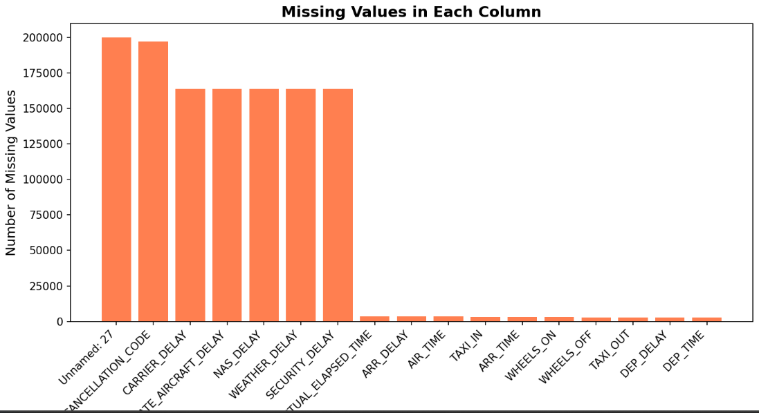
Figure 4: Missing value count per column using isnull().sum()
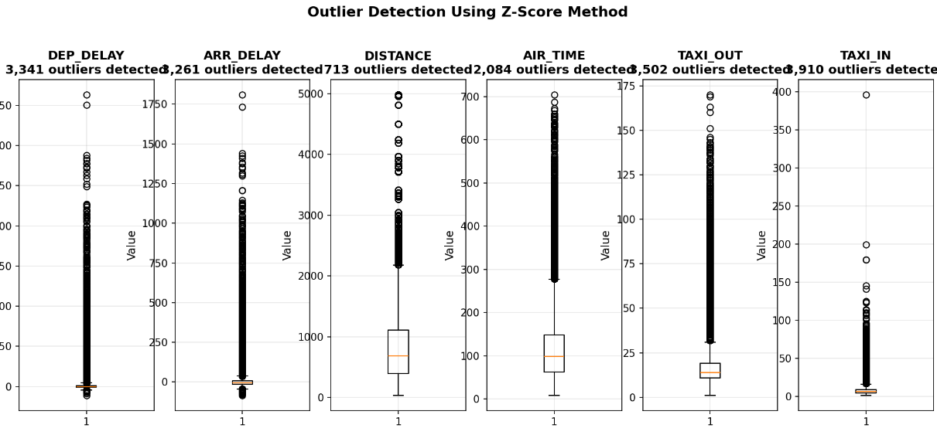
Figure 5: Missing value handling — imputation applied to delay columns

3.3 Outlier Detection and Treatment
Outlier detection was performed using the Z-score method, which flags values that fall beyond ±3 standard deviations from the column mean. This method is straightforward to implement and interpret, making it suitable for a dataset of this scale. Boxplots were also generated to provide a visual confirmation of the outlier distribution in the delay columns.
Upon inspection, extreme delay values were found to be genuine data points — they represent real, exceptional disruptions — rather than data entry errors. However, since the goal of this project is to understand typical delay patterns rather than model extreme events, a domain-informed capping strategy was applied. DEP_DELAY and ARR_DELAY were constrained to ±40 minutes using numpy's clip() function. This threshold aligns with standard aviation reporting conventions, where delays exceeding 40 minutes are operationally classified as significant disruptions and treated separately.

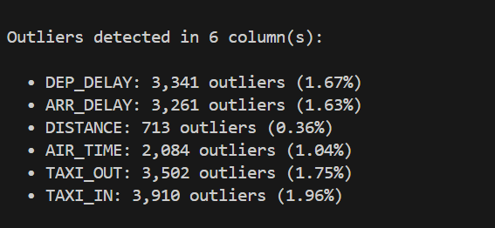
Figure 6: Outlier detection using Z-score method
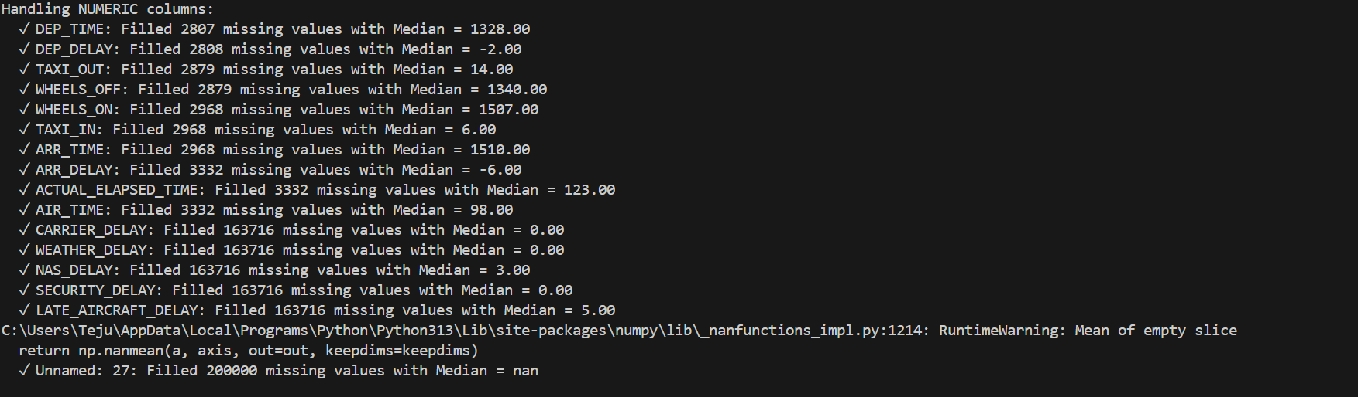
Figure 7: Boxplot showing outlier distribution in delay columns
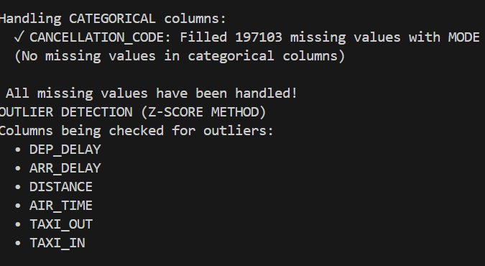
Figure 8: Dataset after outlier capping — cleaned distribution

3.4 Data Quality Report Summary
After completing all preprocessing steps, the cleaned dataset was ready for exploratory analysis. The table below summarizes the state of the data before and after preprocessing:
Metric | Before Cleaning | After Cleaning
Total Rows | 200,000 | 200,000
Missing Values | Present in 5+ columns | None
Duplicate Rows | Not detected | None
Outliers in Delay Cols | Present (extreme values) | Capped at ±40 min
Empty Columns | Unnamed: 27 (empty) | Dropped
Data Types | Mixed / inconsistent | Standardized
Columns Count | 28 | 27

Chapter 4: Exploratory Data Analysis

4.1 Univariate Analysis
Univariate analysis was conducted on all key numerical and categorical columns to understand their individual distributions. For numerical features such as DEP_DELAY, ARR_DELAY, and DISTANCE, histograms were plotted and revealed strong right skewness in the delay columns — confirming that many flights experienced either no delay or minor delays, while a small proportion of flights experienced significant disruptions that stretched the distribution tail.
For categorical features, flight status distribution was examined. The analysis revealed that approximately 64% of flights were classified as on-time (arrival delay of 15 minutes or less), 34.5% were delayed, and 1.4% were cancelled. This distribution provides a clear baseline for understanding the scale of the delay problem across the dataset.

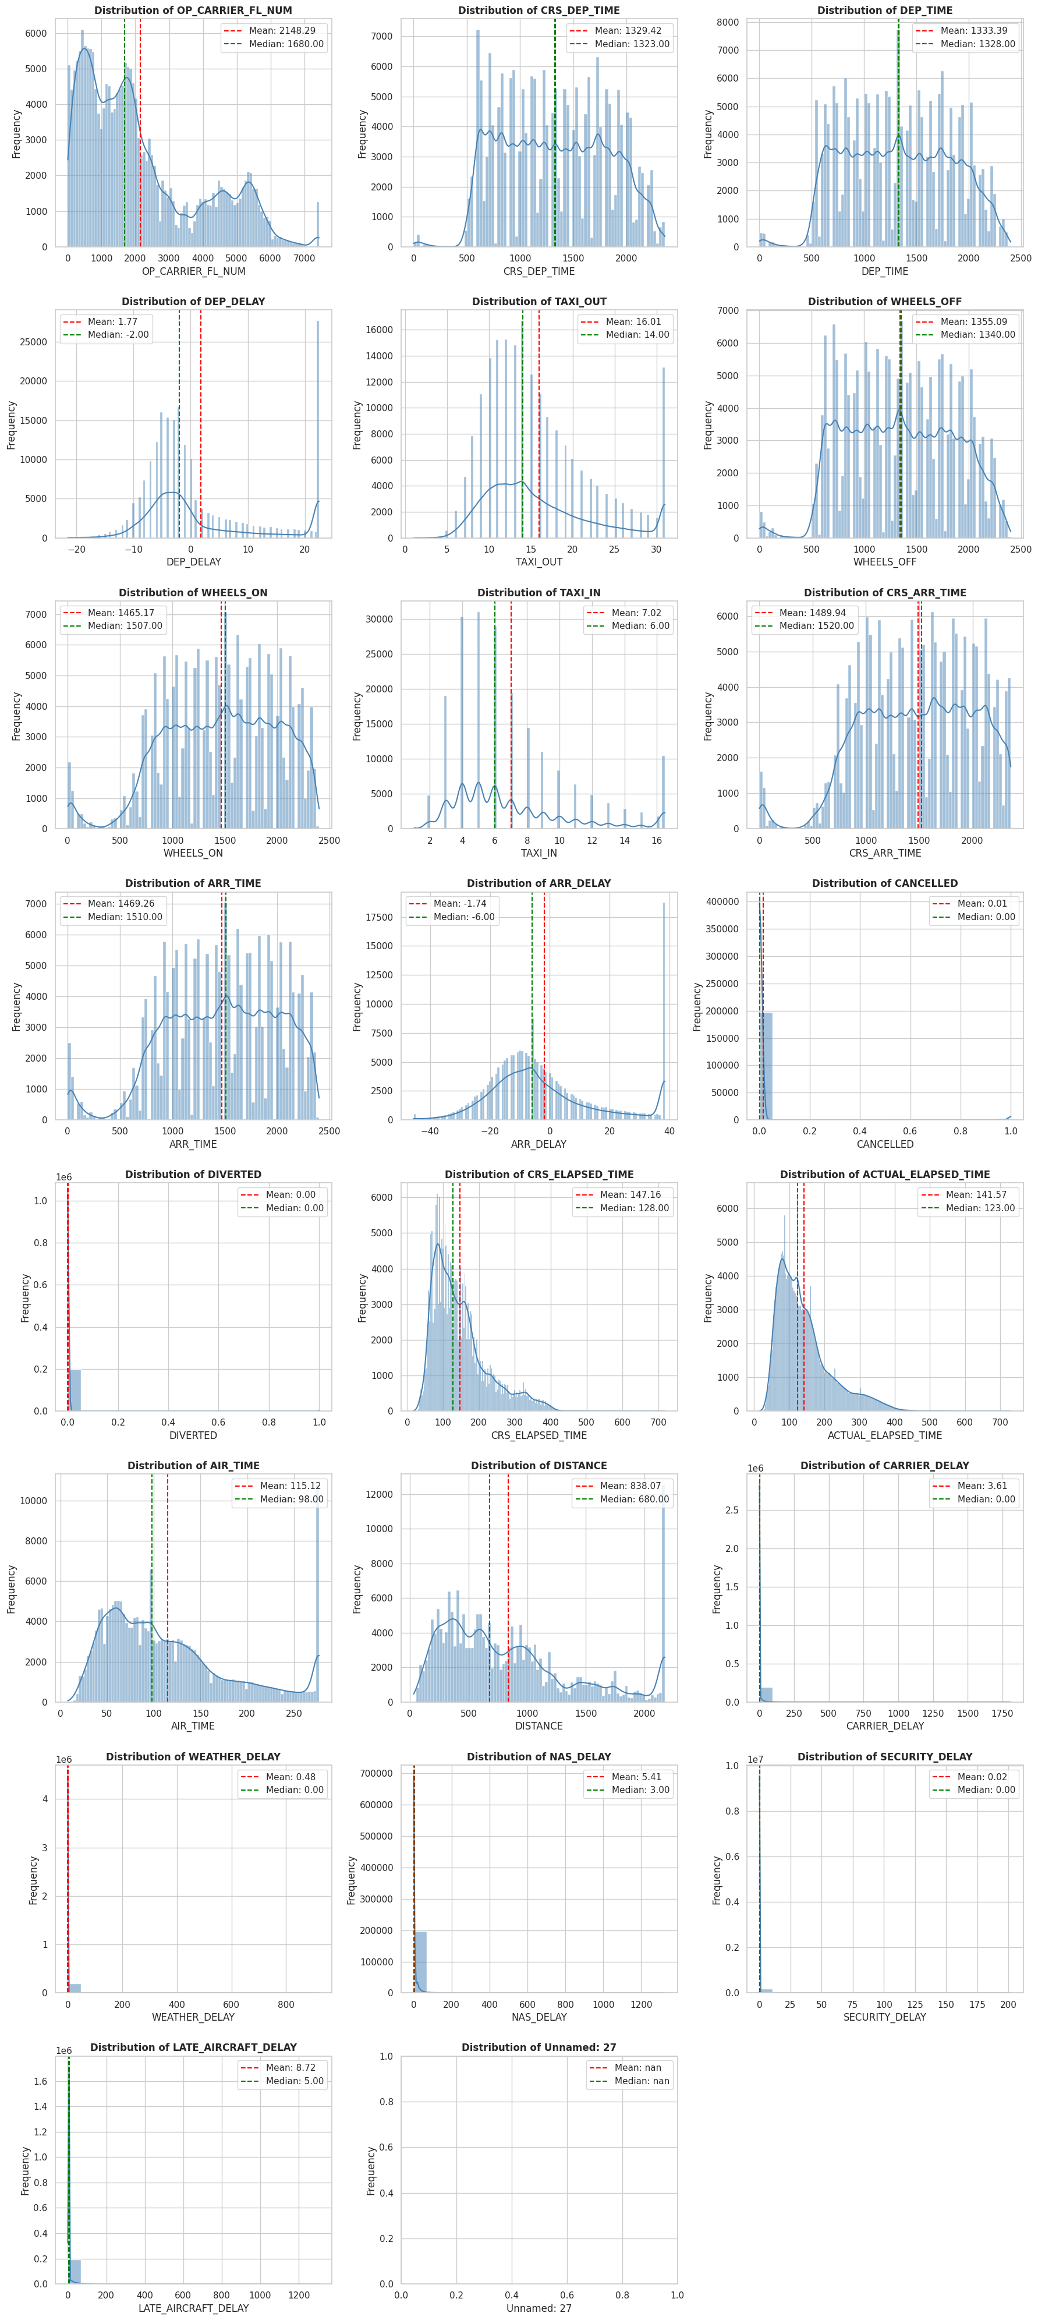
Figure 9: Univariate distribution plots for key numerical columns
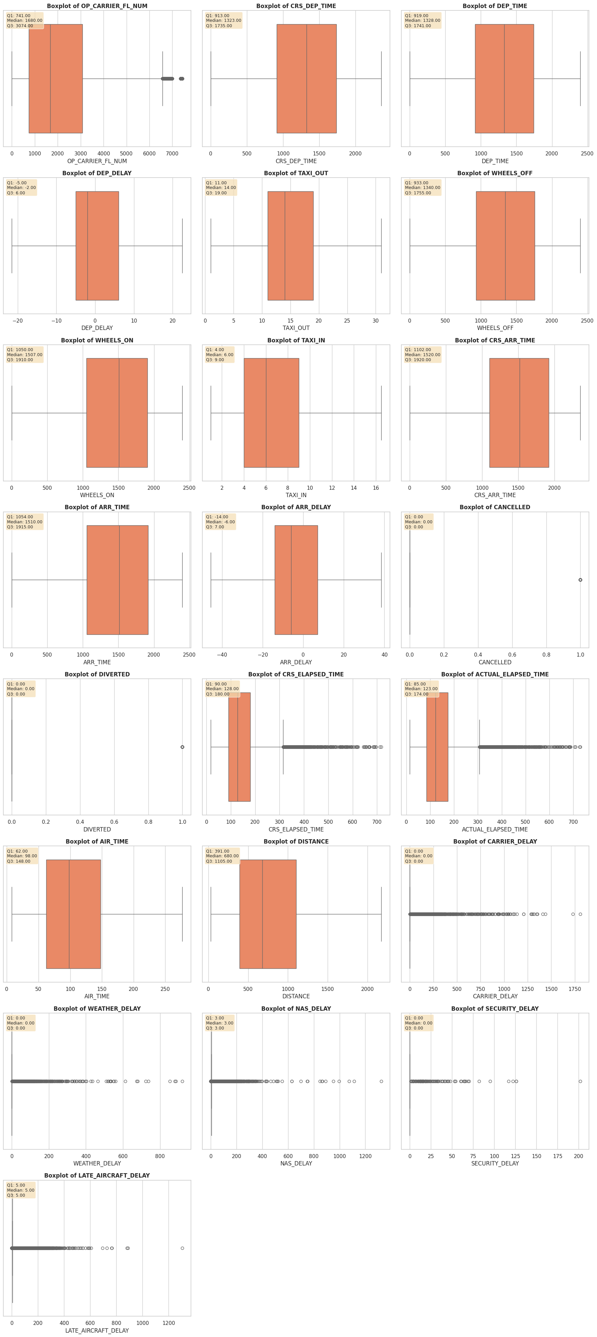
Figure 10: Flight status distribution showing On-Time, Delayed, and Cancelled proportions

4.2 Bivariate Analysis
Bivariate analysis explored relationships between pairs of variables to uncover patterns that single-column analysis cannot reveal. Several important relationships were identified:
- Carrier-wise delay analysis: A bar chart comparing average arrival delay by OP_CARRIER showed significant variation across airlines. ExpressJet (EV) and Frontier (F9) consistently showed the highest average delays, while Alaska Airlines (AS) and Hawaiian Airlines (HA) demonstrated the best on-time performance.
- Airport-level analysis: Major hub airports showed higher average delays than smaller regional airports, reflecting the impact of higher traffic volume and congestion on delay propagation.
- Monthly trend analysis: A line chart of average delay by month revealed seasonal peaks during June-July (summer travel season) and December-January (winter holiday season), corresponding to periods of maximum demand and adverse weather conditions respectively.
- Correlation analysis: A near-perfect positive correlation (>0.90) was found between DEP_DELAY and ARR_DELAY. This provides strong quantitative evidence for the cascading delay phenomenon — a flight that departs late almost always arrives late, and the margin rarely recovers in transit.

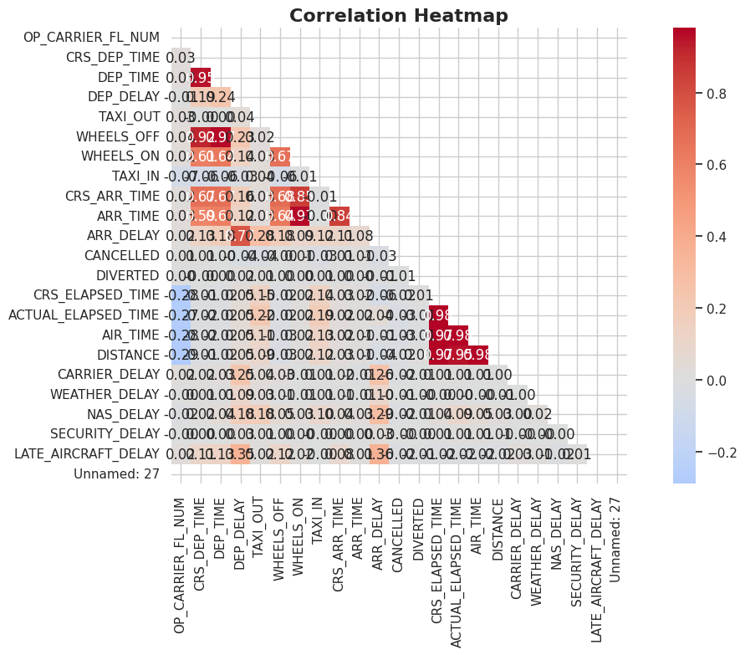
Figure 11: Multivariate analysis — Airline-wise average departure and arrival delays
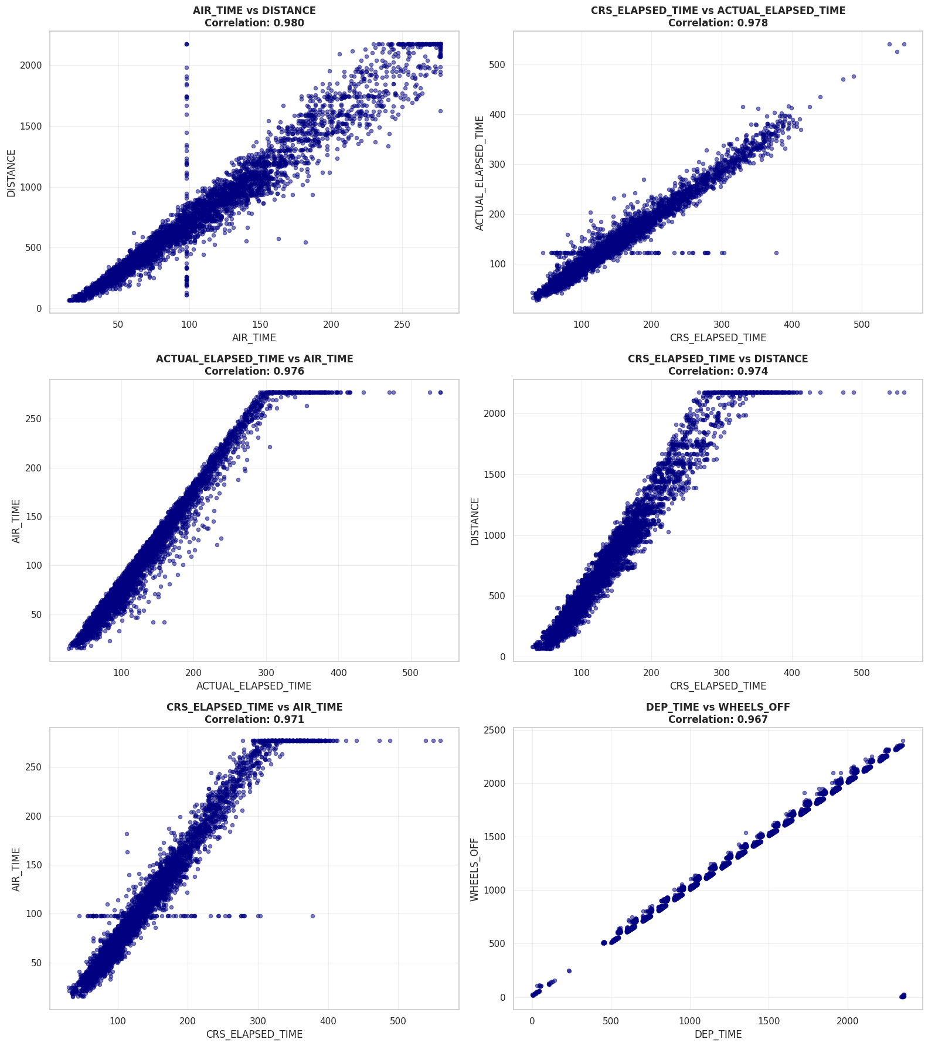
Figure 12: Monthly trend of average delays across 2017 (seasonal patterns)

4.3 Key Observations and Patterns
- The "Late In, Late Out" effect is strongly validated: departure delay and arrival delay are almost perfectly correlated, confirming that the aviation network has very limited recovery capacity once a delay begins.
- Carrier-level performance varies significantly, suggesting that operational factors — not just weather or external conditions — are major contributors to delay patterns.
- Seasonal peaks in June-July and December-January align perfectly with known periods of high travel demand and weather risk, confirming that external conditions do play a role alongside operational factors.
- Cancellation rates are relatively low at 1.4%, but their impact on passengers is disproportionately high due to downstream rebooking cascades.

Chapter 5: Data Transformation and Feature Engineering

5.1 Feature Scaling
Feature scaling was applied to normalize the range of numerical columns before feeding the data into machine learning-compatible formats. RobustScaler from scikit-learn was chosen for this purpose. Unlike StandardScaler — which uses mean and standard deviation — RobustScaler uses the median and interquartile range (IQR) for scaling. This makes it inherently resistant to the influence of outliers, which are an unavoidable characteristic of flight delay data even after capping. Using StandardScaler in this context would have allowed the few remaining extreme values to distort the scaling of the entire column.

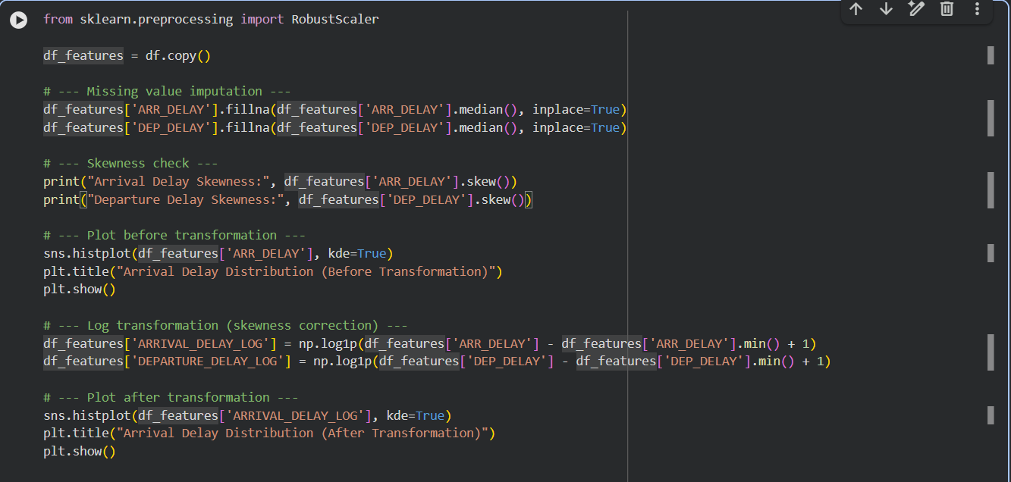
Figure 13: Feature scaling using RobustScaler — code and implementation
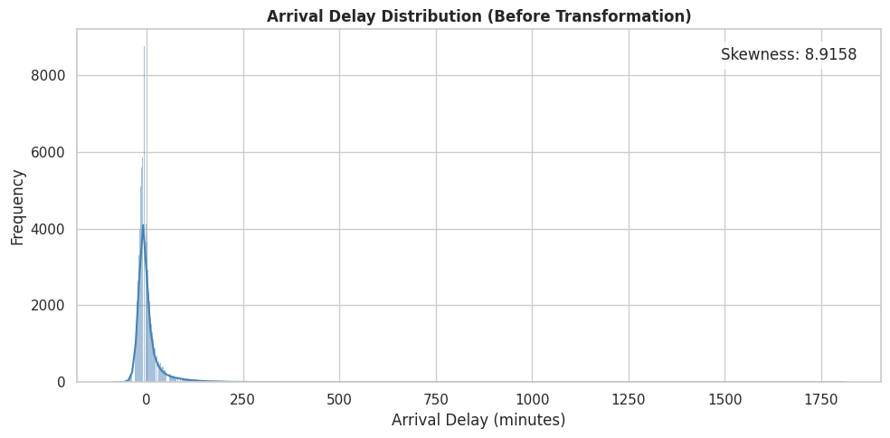
Figure 14: Distribution of DEP_DELAY before scaling
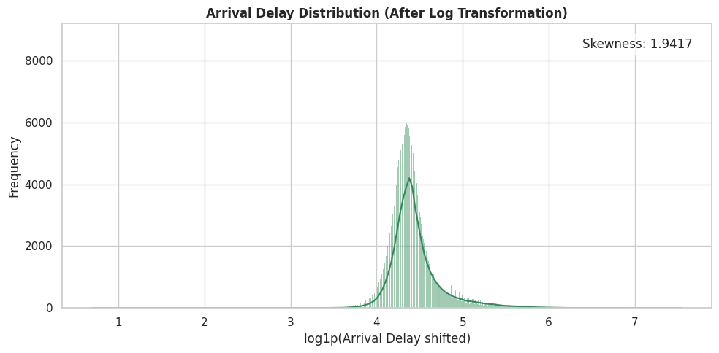
Figure 15: Distribution of DEP_DELAY after RobustScaler transformation

5.2 Encoding Techniques
One-Hot Encoding (OHE) was applied to the three high-cardinality nominal categorical columns: OP_CARRIER, ORIGIN, and DEST. The pd.get_dummies() function from pandas was used for this purpose. The decision to use OHE rather than LabelEncoder was deliberate and methodologically important. LabelEncoder assigns integer values to categories in alphabetical order, implying an ordinal relationship between them — for example, it would suggest that carrier "WN" is numerically greater than carrier "AA," which has no real-world meaning. Since carrier codes and airport codes are purely nominal categories with no inherent order, OHE is the correct approach as it creates independent binary columns for each category without introducing false numerical relationships.
This encoding expanded the dataset from approximately 15 working columns to approximately 670 columns — a significant increase that underscores the need for dimensionality reduction techniques in the subsequent chapter.

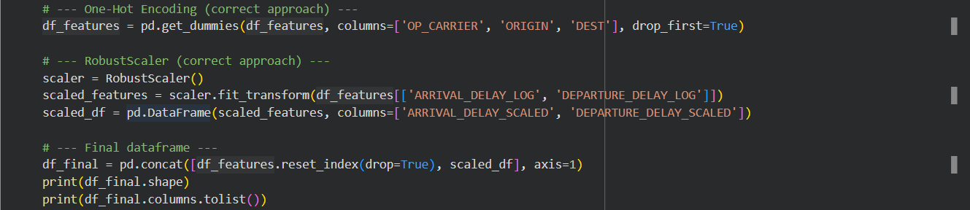
Figure 16: One-Hot Encoding applied to OP_CARRIER, ORIGIN, and DEST
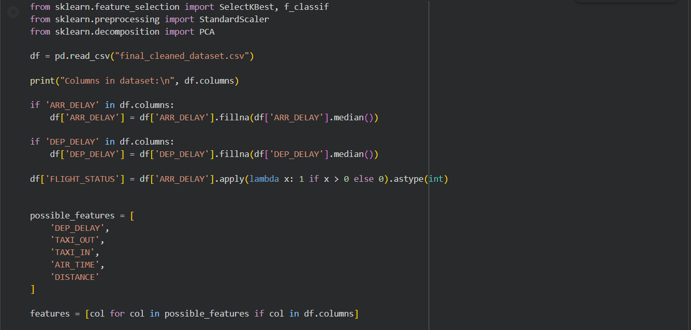
Figure 17: Dataset expansion from ~15 to ~670 columns after OHE

5.3 Handling Skewness
Both ARR_DELAY and DEP_DELAY exhibited significant positive skewness before transformation, with long right tails caused by occasional extreme delays. This skewness can negatively affect the performance of machine learning models that assume normally distributed inputs. To address this, log transformation using numpy's log1p() function was applied to both columns. The log1p() variant was chosen specifically because it handles zero values correctly (log(0) is undefined, but log1p(0) = 0), which is important given that many flights have zero delay.
After transformation, skewness values dropped close to zero for both columns, producing approximately symmetric distributions. A notable spike is visible in the post-transformation histogram — this is an expected and documented artifact of the outlier capping performed in Chapter 3. All values that were capped at the ±40 minute boundary map to the same log value, creating a concentration spike at that point rather than a smooth curve. This is not an error; it is a direct consequence of the capping strategy.

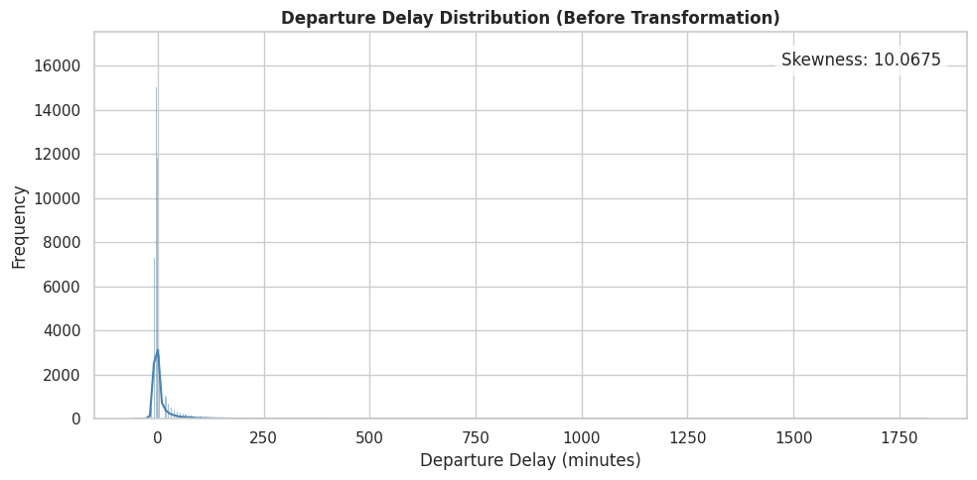
Figure 18: ARR_DELAY distribution before log transformation (right-skewed)
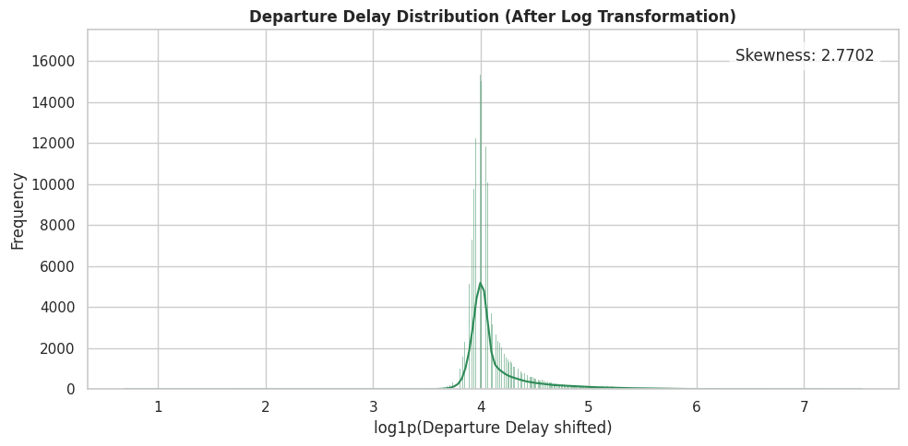
Figure 19: ARR_DELAY distribution after log1p transformation (near-symmetric)

5.4 Feature Engineering Summary
Technique | Applied To | Reason
RobustScaler | DEP_DELAY, ARR_DELAY, numeric columns | Robust to outliers in skewed delay data
Log Transformation (log1p) | DEP_DELAY, ARR_DELAY | Correct positive skewness for model readiness
One-Hot Encoding | OP_CARRIER, ORIGIN, DEST | Nominal categories with no ordinal relationship
Outlier Capping (±40 min) | DEP_DELAY, ARR_DELAY | Domain-based threshold, prevents distortion

Chapter 6: Advanced Analysis

6.1 Correlation Analysis
A Pearson correlation heatmap was generated using seaborn to systematically examine linear relationships between all numerical features. The strongest correlation in the dataset was between DEP_DELAY and ARR_DELAY at greater than 0.90, providing formal statistical confirmation of the cascading delay hypothesis that was observed qualitatively during EDA. Moderate positive correlations were also found between TAXI_OUT and DEP_DELAY, and between LATE_AIRCRAFT_DELAY and ARR_DELAY, further reinforcing that ground operations play a meaningful role in the overall delay chain.

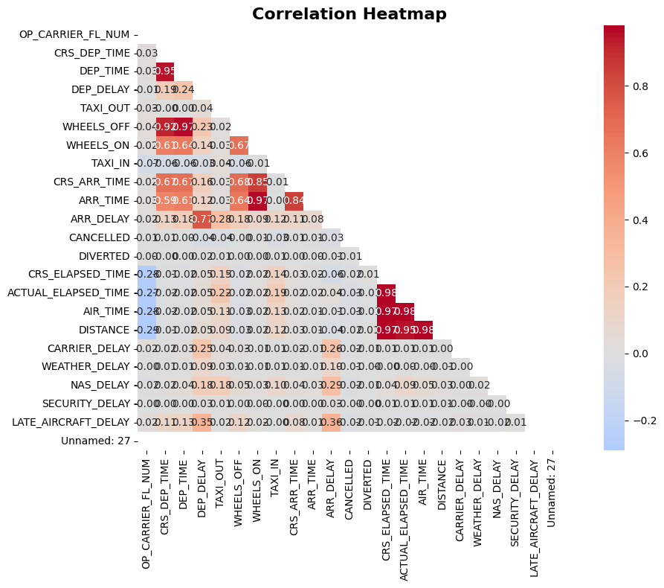
Correlation Heatmap

6.2 Feature Selection
Feature selection was performed using SelectKBest with the f_regression scoring function from scikit-learn. This method evaluates each feature's statistical relationship with the target variable (ARR_DELAY) and retains the top K most informative ones. The top features consistently identified were: DEP_DELAY (strongest predictor), TAXI_OUT, and TAXI_IN. This makes intuitive operational sense — a flight that departs late or spends excessive time taxiing will almost certainly arrive late. The feature selection results also helped confirm that delay cause attribution columns (CARRIER_DELAY, WEATHER_DELAY, etc.) are important secondary contributors.

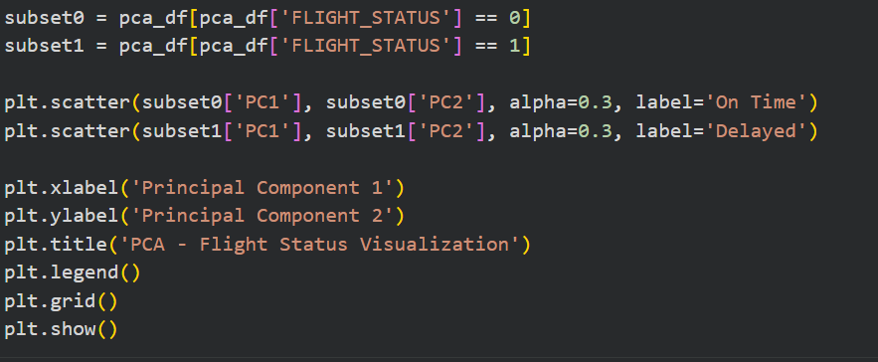
Figure 20: SelectKBest feature importance scores for ARR_DELAY prediction

6.3 Principal Component Analysis (PCA)
PCA was applied after RobustScaling to reduce the dimensionality of the one-hot encoded dataset, which had expanded to approximately 670 columns after encoding. StandardScaler was reapplied immediately prior to PCA since PCA is a variance-sensitive technique that requires features to be on a comparable scale. The first two principal components together explained approximately 68% of the total variance in the dataset — a strong result indicating that a large proportion of the information content can be captured in just two dimensions.

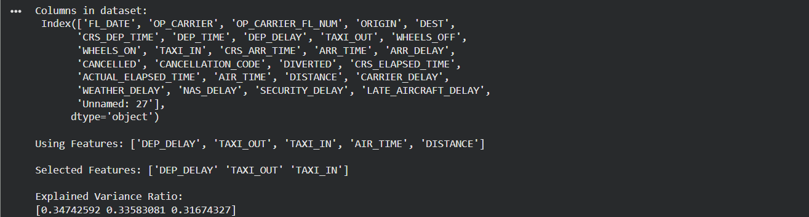
Figure 21: PCA explained variance per component
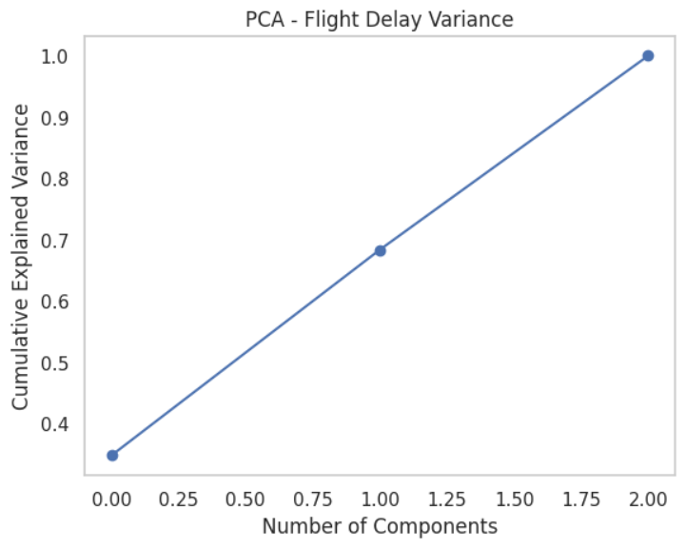
Figure 22: Scree plot showing cumulative explained variance
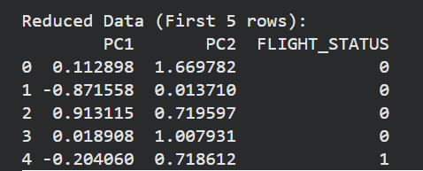
Figure 23: Variance retained by top principal components

6.4 Visualization of PCA Components
A 2D PCA scatter plot was generated with data points coloured by flight status (On-Time vs. Delayed). The visualization revealed a clear and meaningful pattern: delayed flights exhibit significantly higher spread and variability in PCA space, while on-time flights cluster much more tightly together. This finding suggests that delays are driven by a wide and heterogeneous combination of operational factors, rather than a single dominant cause — which aligns with the multi-factor delay attribution data observed during EDA.

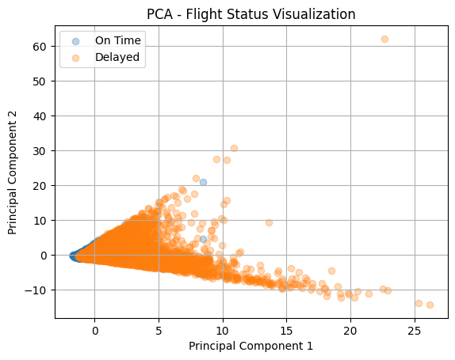
Figure 24: PCA 2D scatter plot coloured by flight status (On-Time vs Delayed)

Chapter 7: Visualization and Dashboard

7.1 Tools Used
Two primary tools were used for visualization in this project. Python — with matplotlib and seaborn libraries — was used for all analytical visualizations during the EDA, feature engineering, and advanced analysis phases. These included distribution plots, bar charts, line charts, scatter plots, boxplots, heatmaps, and PCA visualizations. Power BI Desktop was used as the dedicated dashboard development tool for the final interactive reporting layer, leveraging DAX measures, a star schema data model, and multiple visual types to create an executive-level analytical dashboard.

7.2 Types of Visualizations Used
Visual Type | Purpose / Insight Delivered
KPI Cards | Display Total Flights, Avg Dep Delay, Avg Arr Delay, On-Time Rate %
Donut Chart | Flight status distribution — On-Time vs Delayed vs Cancelled proportions
Gauge Chart | On-Time Rate visualized as a 0–100% gauge for at-a-glance assessment
Stacked / 100% Stacked Bar Chart | Delay cause breakdown per carrier (Carrier / Weather / NAS / Late Aircraft)
Matrix Heatmap | Average delay by Hour of Day × Day of Week — identifies high-risk windows
Line Chart | Monthly average delay trend across all 12 months of 2017
Horizontal Bar Chart | Carrier-wise ranking by average arrival delay
Scatter Plot | Departure delay vs Arrival delay — confirms cascading effect correlation
Pie Chart | Proportion of flight statuses across the dataset

7.3 Dashboard Architecture
The Power BI dashboard was built on a clean, star-schema data model. A DAX-generated Date table was created using the CALENDAR() function and linked to the fact table via the FL_DATE column, enabling proper time intelligence functions. All measures — including Total Flights, Avg Departure Delay, Avg Arrival Delay, On-Time Rate %, % Cancelled, % Diverted, and all five delay cause averages — were written as explicit DAX measures and stored in a dedicated _Measures table for organizational clarity.
The dashboard consists of two pages. Page 1 serves as an executive overview, featuring KPI cards, a flight status donut chart, a gauge visual for on-time rate, and a 100% stacked bar for status distribution. Page 2 provides a deeper operational view, with the hour-day heatmap matrix for identifying high-risk departure windows and a multi-series bar chart for delay cause attribution by carrier. Slicers for OP_CARRIER and Month were configured with Sync Slicers enabled, allowing filters to apply consistently across both pages without duplication.

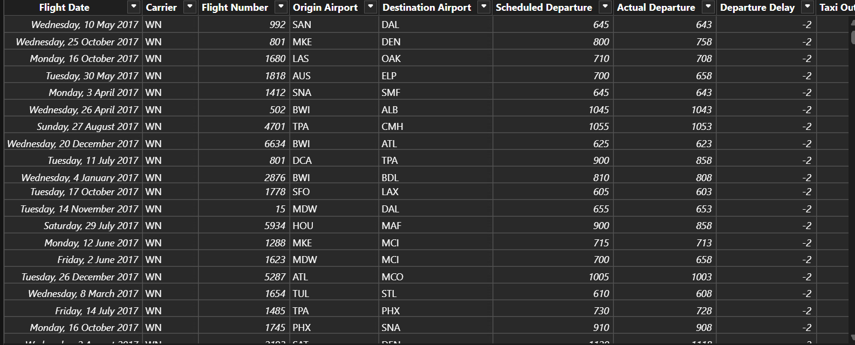
Figure 25: Transformed dataset loaded into Power BI
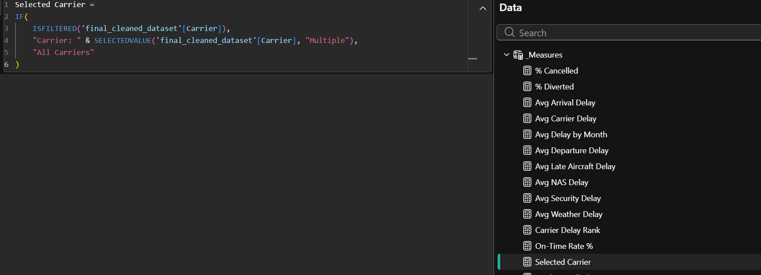
Figure 26: DAX Date table and core measures in Power BI
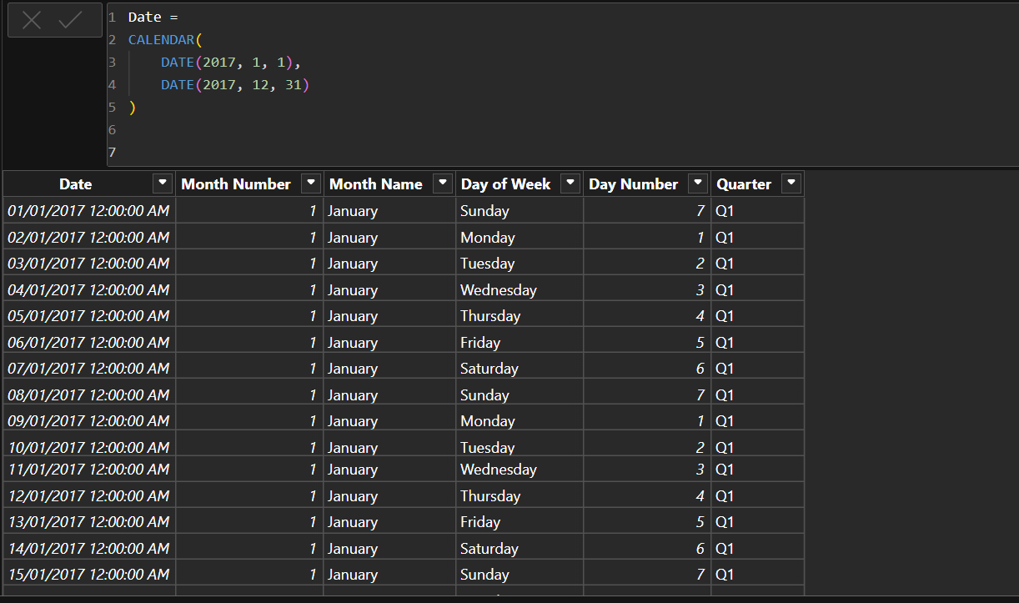
Figure 27: DAX measures for delay cause attribution
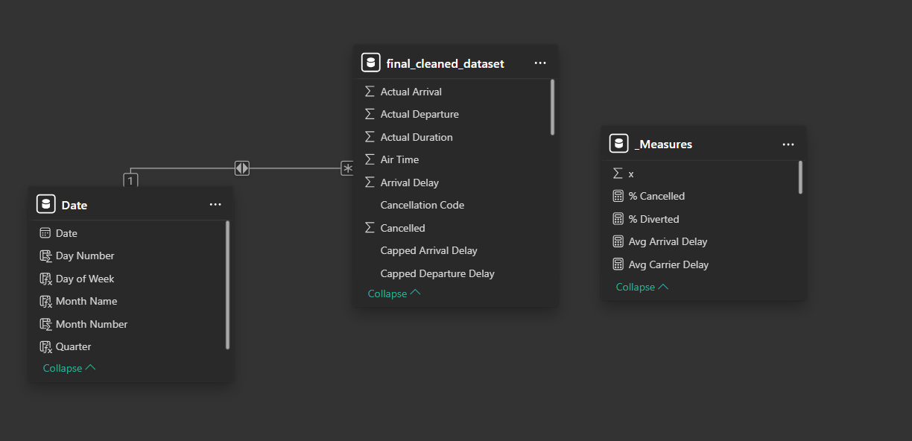
Figure 28: Relationships view — star schema data model
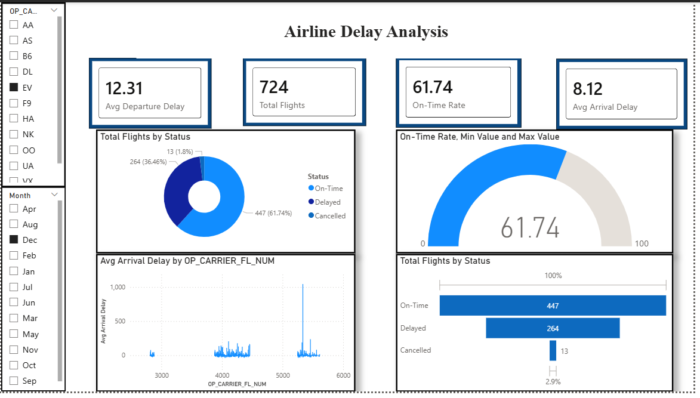
Figure 29: Power BI Dashboard — Page 1 (Overview with KPI cards and status distribution)

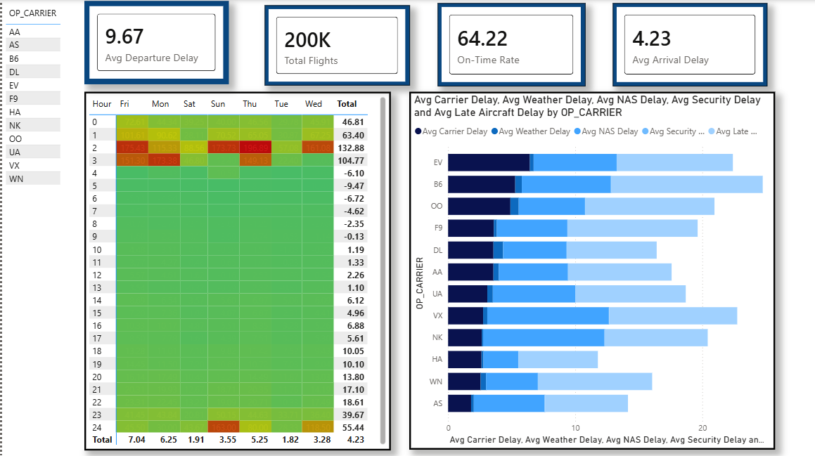
Figure 30: Power BI Dashboard — Page 2 (Heatmap and delay cause breakdown by carrier)

Chapter 8: Insights and Storytelling

8.1 Key Findings
- The overall on-time rate for U.S. domestic flights in 2017 was 64%, meaning approximately 1 in every 3 flights did not arrive on schedule. This is a significant reliability gap that has direct financial and passenger experience implications.
- Late Aircraft Delay was the single largest contributor to total delay across all carriers in the dataset. Its dominance across the stacked bar chart confirms that the aviation network is highly sensitive to early-day disruptions that cascade forward through the day.
- ExpressJet (EV) and JetBlue (B6) were consistently the worst-performing carriers across multiple delay categories, while Alaska Airlines (AS) and Southwest Airlines (WN) maintained the best relative on-time performance.
- Flights departing between midnight and 4 AM experienced the highest average delays — sometimes exceeding 100 minutes at 3 AM — driven by the accumulation of disruptions from the previous operational day.
- Thursdays and Sundays showed structurally higher delays compared to other days of the week, particularly during the evening and early-morning hours, pointing to peak demand and insufficient buffer scheduling.

8.2 Patterns and Trends Identified
Delay patterns in this dataset are cyclical by time of day. Delays tend to be minimal in the early morning (5–8 AM), build steadily through the day as individual disruptions accumulate, peak in the late evening (9 PM–midnight), and reach their worst levels in the early morning hours of the following day. This pattern is consistent with the well-documented cascading effect of aviation delays.
Seasonally, delay rates peak during June–July (summer travel season) and December–January (winter holiday season). These peaks correspond to maximum passenger demand combined with higher weather risk — particularly thunderstorms in summer and winter storms in December–January — creating a compounding effect on delay rates.
At the carrier level, performance is not uniformly distributed. A small number of carriers account for a disproportionately large share of total delay minutes, suggesting that operational quality varies significantly and is not purely a function of external conditions like weather.

8.3 Business and Social Insights
From an airline operations perspective, the dominance of Late Aircraft Delay as the primary cause points clearly to turnaround time as the most impactful lever for improvement. If airlines can reduce the time it takes to turn around an aircraft between flights — through faster boarding, more efficient ground handling, and better gate management — they can significantly reduce the cascading effect that drives the majority of delays.
From a passenger perspective, the analysis provides actionable booking guidance. Passengers should avoid late-night departures, particularly those departing after 9 PM, as these accumulate the delays of the entire day. Choosing carriers with historically strong on-time performance — such as AS and WN — and avoiding high-risk days like Thursday and Sunday evenings can materially improve travel reliability.
From an airport management perspective, the heatmap analysis identifies specific hour-day combinations as structurally high-risk. Airport authorities at major hubs should pre-position additional ground staff, gate agents, and operations managers during Thursday and Sunday evenings and the late-night window between 9 PM and 1 AM.

8.4 Decision-Making Based on Results
Stakeholder | Recommended Action Based on Analysis
Airlines (worst performers: EV, B6) | Invest in faster turnaround protocols; restructure schedules to build recovery buffers after peak hours
Airlines (all carriers) | Introduce schedule padding during summer and winter peak seasons; reduce reliance on late-night departure slots
Airport Authorities | Deploy additional ground resources on Thursday and Sunday evenings; monitor the 9 PM–1 AM window as a high-risk period
Passengers / Travel Planners | Prefer morning departures; choose AS or WN over EV or B6 for time-sensitive travel; avoid Thursday and Sunday evenings
Policy Makers (DOT) | Use delay attribution data to identify carriers with persistently high avoidable delay rates and mandate operational improvement plans

Chapter 9: Conclusion

9.1 Summary of the Project
This project conducted an end-to-end data science analysis of approximately 200,000 U.S. domestic flight records from 2017, sampled reproducibly from a dataset of nearly 5 million records. The full pipeline covered data loading and inspection, missing value treatment using median and mode imputation, outlier detection and domain-based capping at ±40 minutes, exploratory data analysis through univariate and bivariate methods, feature engineering including RobustScaling and One-Hot Encoding, skewness correction via log transformation, dimensionality reduction using PCA, and the development of a fully interactive Power BI dashboard with DAX measures, a star schema data model, and cross-page synchronized slicers.

9.2 Outcomes Achieved
- All planned project objectives were successfully completed within the weekly curriculum timeline.
- A clean, analysis-ready dataset was produced with no missing values, standardized data types, and properly capped outliers.
- EDA revealed significant and actionable patterns in delay distribution by carrier, time of day, and day of week.
- Feature engineering produced a transformed dataset with corrected skewness and properly encoded categorical variables, suitable for downstream machine learning.
- PCA confirmed that departure delay and taxi time are the most variance-explaining operational factors for predicting arrival delay.
- The Power BI dashboard successfully communicates eight distinct types of visualizations with dynamic filtering capability, accessible to both technical and non-technical stakeholders.

9.3 Limitations
- The analysis is based on a 200,000-row sample, which — while statistically representative — may not fully capture rare events such as large-scale weather disruptions or systemic failures that affect only a small number of flights.
- The dataset covers only the calendar year 2017 and does not account for structural changes in the aviation industry, regulatory changes, or shifts in carrier operations that have occurred since.
- Predictive modelling (e.g., classification or regression to forecast delay probability) was outside the scope of this project.
- The Power BI dashboard requires manual data refresh and is not connected to a live or near-real-time data source.

9.4 Future Scope
- Incorporating multi-year data (2015–2023) would allow long-term trend analysis and enable the identification of structural shifts in delay patterns, including the impact of COVID-19 on the aviation industry.
- Predictive models — such as Random Forest or XGBoost classifiers — could be trained to forecast whether a given flight will be delayed based on its scheduled features, providing airlines with proactive operational warnings.
- Real-time delay prediction could be explored by integrating live ATC feeds, weather APIs, and airline operational data streams into the analytical pipeline.
- Network analysis techniques could be applied to model delay propagation across the national airport graph, identifying which airports act as systemic bottlenecks that amplify delays network-wide.

Chapter 10: References
No. | Reference
1 | Kaggle Dataset — U.S. DOT Flight Delays: https://www.kaggle.com/datasets/usdot/flight-delays/data?select=flights.csv
2 | Pandas CSV Reading: https://www.w3schools.com/python/pandas/pandas_csv.asp
3 | Matplotlib Boxplot: https://www.geeksforgeeks.org/data-visualization/box-plot-in-python-using-matplotlib/
4 | What is EDA: https://www.geeksforgeeks.org/data-analysis/what-is-exploratory-data-analysis/
5 | EDA Steps — Medium: https://medium.com/@nikhil16kulkarni/day-4-exploratory-data-analysis-eda-cc1786bf0388
6 | Dimensionality Reduction — IBM Think: https://www.ibm.com/think/topics/dimensionality-reduction
7 | PCA with Python — Medium: https://anilpise7.medium.com/dimensionality-reduction-in-machine-learning
8 | PCA GitHub Reference: https://github.com/tirthajyoti/Machine-Learning-with-Python
9 | Power BI Visuals Guide: https://www.datacamp.com/tutorial/power-bi-visuals-beginner-guide
10 | scikit-learn Documentation: https://scikit-learn.org/stable/
11 | Team GitHub Repository: https://github.com/NamiyaMayilsamy/24ADI004_-DSV_TEAM-16

Appendix

A. GitHub Repository
All source code, weekly scripts, cleaned datasets, and additional visualizations are available at:
https://github.com/NamiyaMayilsamy/24ADI004_-DSV_TEAM-16

B. Team Contributions per Week
Week | Anbusabarivasan (09) | Ibrahim (35) | Tejaswi (25) | Namiya (04)
Week 1 | Dataset search and validation | Lab documentation | Pandas implementation | NumPy implementation
Week 2 | Dataset structure exploration | Lab documentation | Pandas .info()/.describe() | NumPy implementation
Week 3 | Missing value analysis | Mean & median imputation | Outlier detection (Z-score) | Data validation
Week 4 | Univariate analysis, airline delay calc. | Correlation & cascading effect | Visualizations (pie, bar, line, scatter) | Monthly trend analysis
Week 6 | Skewness handling, log transform | Feature selection, PCA | Distribution plots, variance plot | PCA output validation
Week 7 | Feature engineering | SelectKBest, PCA reduction | PCA scatter plot | PCA result interpretation
Week 8 | Power BI — Overview & Trends | Power BI — Routes & Design | DAX Measures & Data Model | Data Preparation & Power Query

C. Key Libraries and Tools Used
Library / Tool | Version / Notes | Purpose
Python | 3.x | Primary programming language
pandas | Latest stable | Data loading, cleaning, transformation
numpy | Latest stable | Numerical operations, log transform, clipping
matplotlib | Latest stable | Plot generation (histograms, bar charts, line charts)
seaborn | Latest stable | Statistical plots (heatmaps, boxplots, scatter plots)
scikit-learn | Latest stable | RobustScaler, SelectKBest, PCA
Power BI Desktop | 2026.03 | Interactive dashboard, DAX measures, data model
Google Colab | Cloud | Python execution environment
GitHub | Cloud | Version control and team collaboration

